Johnlee Alvarez

2/11/16

CSCI 3656

Problem Set 4

1a. 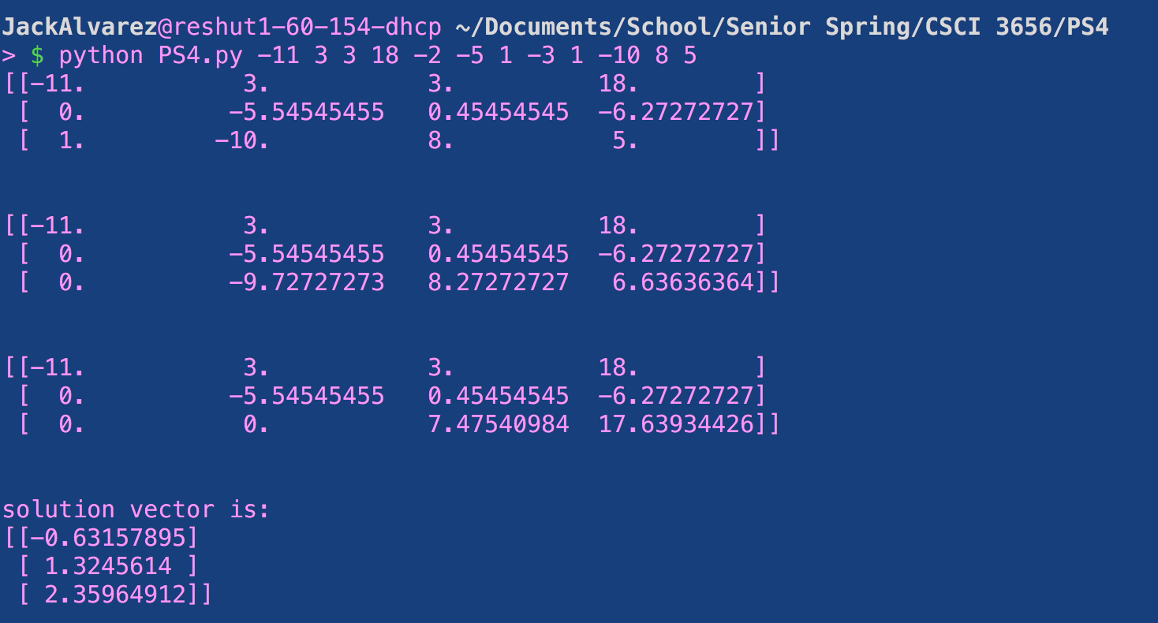

1b. 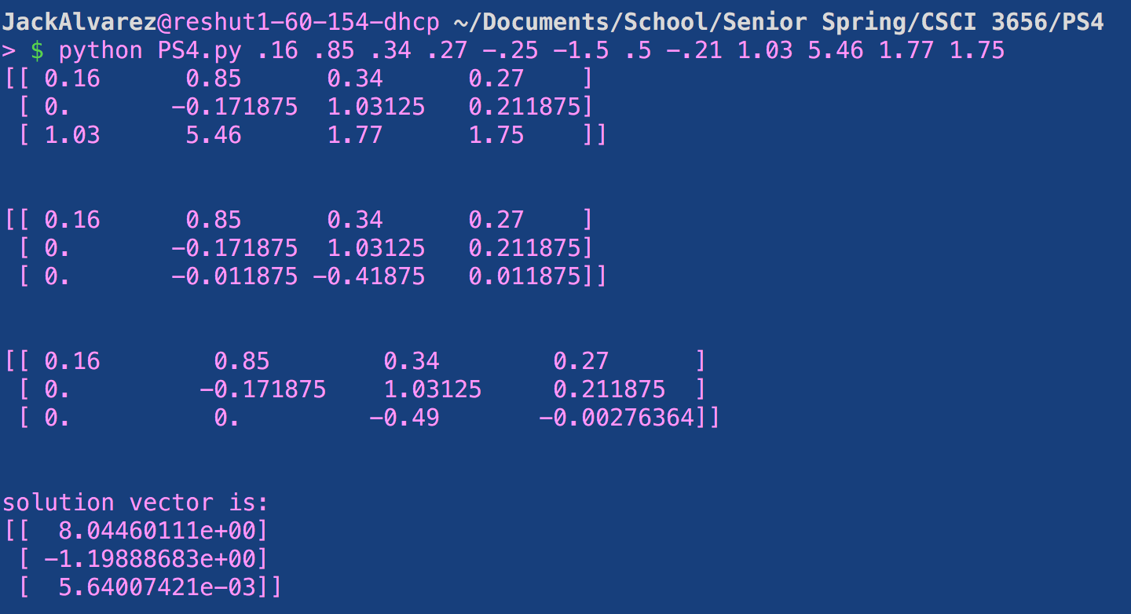

1c. 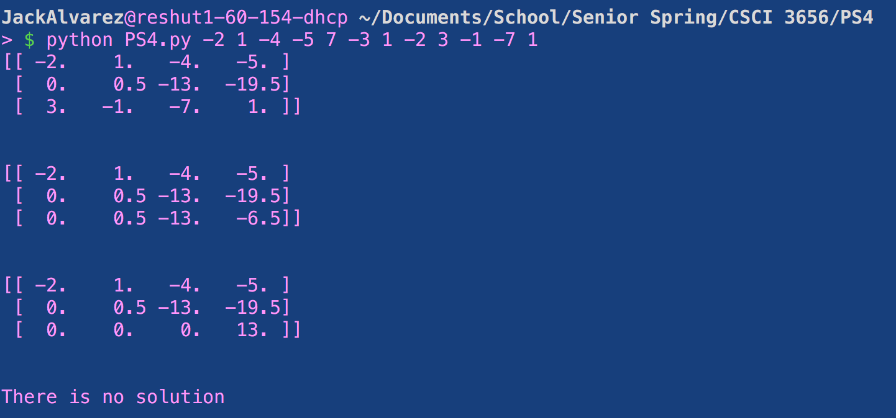

2. 8, 4089, 1.8E17. The condition number according to class and Sauer is the “error magnification factor”. A large condition number (of the order 100, 1000, or greater) is generally a bad sign because the calculation of inv(A) is problematic. In the case of 1c, you can see that there is no solution with X3 getting canceled out and the condition number for this case is huge.

